**ABOUT US**

Energy Systems Catapult was set up to accelerate the transformation of the UK’s energy system and ensure UK businesses and consumers capture the opportunities of clean growth.

The Catapult is an independent, not-for-profit centre of excellence that bridges the gap between industry, government, academia and research.

We take a whole system view of the energy sector, helping us to identify and address innovation priorities and market barriers to decarbonise the energy system at least cost.

**CASE STUDY**

PESO Project Smart Energy Technologies

Cost effectively decarbonising port activities and improving air quality.

In a project co-funded by Innovate UK, Portsmouth International Port, working with Swanbarton, MSE International, and Energy Systems Catapult (ESC) has showcased how port infrastructure can meet the challenges of the UK Government’s ‘Clean Maritime Plan’.

PESO (Port Energy Systems Optimisation) has demonstrated how ports can use energy storage and smart grid technologies to decarbonise their activities, and reduce their impact on air quality, more cost effectively than would otherwise have been possible.

**The Innovation**

The PESO technical capability has been demonstrated in a pilot system comprising a novel dual chemistry battery and a multi-level control system. The control system includes an AI-based capability that learns from historic energy consumption profiles to ensure that the battery can deliver as much energy as possible when demand is high.

The technology has been extended further by engineering a predictive ‘digital twin’ model that can ensure the battery has storage capacity to fully utilise energy generated by on-site renewable generation or procured from the grid at times of low price. This combined capability to minimise the cost of energy needed to supply vessels with energy and to drive the port’s own assets is a critical aspect of the PESO value proposition.

**PORT OF PORTSMOUTH SAID:**

“Our aim is to turn the port into a living laboratory of green technology. We were delighted to collaborate with partners on the PESO project, which has so much potential for the wider ports and shipping industry. Combined with other sustainability initiatives, the findings from the PESO project will help us achieve our ambition of reaching net-carbon zero by 2030, and becoming one of the UK’s first zero emission ports by 2050.”

**Mike Sellers, Port Director**

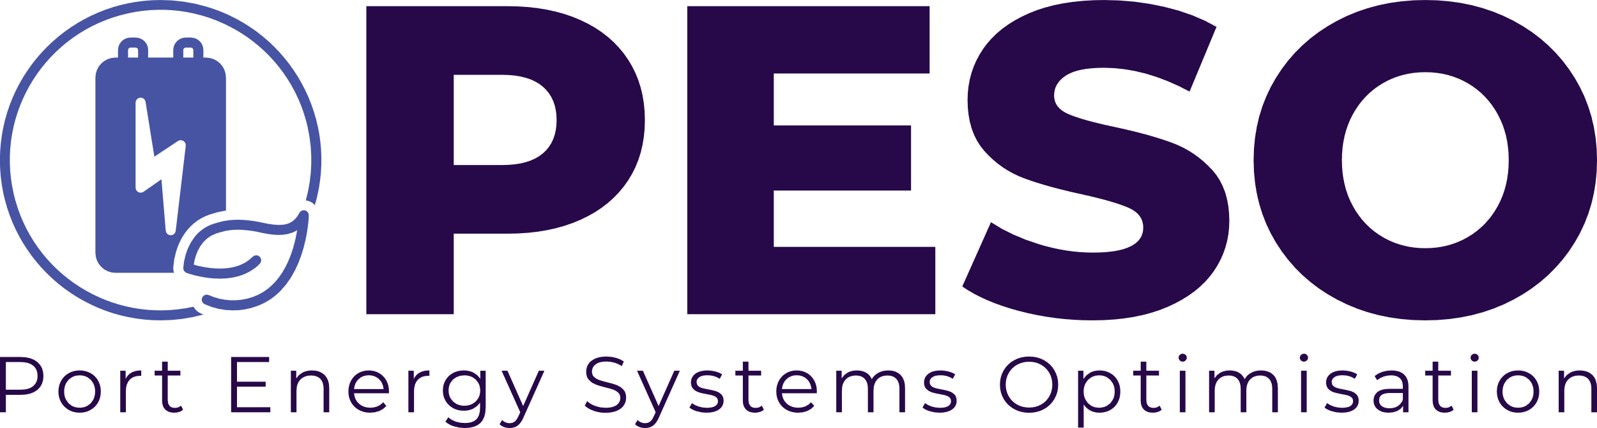

*Port Energy Systems Optimisation (PESO)*

*May 2020 – Jan 2023*

*£83k*



**The Challenge**

The UK’s clean maritime strategy highlighted the role UK ports will play in achieving Net Zero emission goals in the UK. Both in the UK and internationally there is a focus on identifying solutions to reduce energy consumption around ports but also to move away from the use of fossil fuels.

Port decarbonisation is also driven by the need to improve air quality in the area and reduce particulate and NOx emissions.

Ports are major energy users; from dockside operations, to supporting vessels at berth and supporting other activities in the wider port area.

Electrification of port activities and supplying electricity to vessels at berth is driving the need to deploy alternative solutions to minimise the impact on the local area electricity grid and reduce the costs for upgrading network connections.

**The Solution**

To support the project, Energy Systems Catapult focused on value proposition and business case development:

* Desktop research and stakeholder interviews were completed to understand current and future shore power requirements: port operations, freight transport local energy generations & consumption and industrial activities.
* Utilised the Catapult’s modelling capability to assess the value the PESO system could bring to other types of ports.
* Used pilot data to assess the potential opportunities for the PESO system at port.
* Developed the business cases for the PESO system, focusing on current and future port requirements.

**Impact**

The Catapult applied its systems thinking and supported the consortium in identifying future opportunities for the PESO system.

Further, the project has shown that PESO technology can offer value to a wide range of ports:

* Ports where vessel electrification could happen earlier (e.g., passenger ferries, water taxis and leisure boats)
* Ports with diversified activities

Portsmouth International Port has progressed its thinking on decarbonisation and now uses a systems approach to drive forward its Net Zero activities.

The business models ESC assessed highlighted how changes in the energy system could impact port decarbonisation. The Catapult has further enhanced its capabilities and knowledge of port decarbonisation that will be used to support port authorities to decarbonise within future projects.

**Next Steps**

Although PESO has shown an exciting future for this technology in the ports and shipping sector, there remain barriers to overcome:

* The high cost of battery storage.
* The need to collaborate more widely along the value chain for maritime logistics, local authorities, and the energy sector.
* Policy developments on electricity pricing and public investment in the transmission and distribution networks will have a major impact on the PESO proposition to ports. Increasing clarity on such policy development is needed urgently.

The Catapult is using the learnings from the project to support the port of Aberdeen on their Port Zero project and will continue to apply the same system thinking to develop a roadmap to support port operations decarbonise across the public and private sectors.

**Get in touch**

To find out how we can help you, get in touch via email:[info@es.catapult.org.uk](mailto:info@es.catapult.org.uk)

For more information about our Net Zero Sites work, [click here](https://es.catapult.org.uk/what-we-do/net-zero-sites/).